Dear Friends,

In 2017 it has been wonderful to have new friends who were introduced to the farm. Our outdoor LEF space built this year has enjoyed vigorous use by our many visitors. The seed workshops sponsored by the Specialty Crops Grant through the Nebraska Department of Agriculture have brought many new people from Nebraska and other states to learn on the farm. Sixty young people from three Colorado high schools have come for week-long hands on learning sessions. And the farm was able to host 90 people to view the spectacular 2017 solar eclipse.

In 2018, the Living Environment Foundation will be heading up the intern program, aiming for 2-4 interns at Meadowlark Hearth Farm learning about seed growing and marketing, the whole farm approach of Biodynamic agricultural, animal husbandry, and pasture management. We hope to increase the number of people Nathan and Beth can teach before their age no longer allows them to engage in intensive farming. A Medical doctor is developing a summer farm work experience intensive for deaf youth in transition called “Signs of Summer”. We look forward to several weeks working and learning together with them and having the new experience of sign language on the farm. All of these activities require help with planning, housing, hosting facilities and time to teach. We also continue with the ongoing purchase of the land along the river and we hope to begin to make paths to walk through that area.

We applied to work as partners with the Nebraska Master Naturalist Program. Nathan has trained as a Master Naturalist and will do further instructor training to train others. We would also like to engage with more local high schools in the Platte Valley to introduce them to seed growing and how farms can work with conservation programs. We are conversing with the Organic Seed Alliance and MESA (Multi-National Exchange for Sustainable Agriculture) who are earnestly working to diversify people exposed to organic agriculture. We may be able to participate in their international program in the future.

Internship financial assistance: $24,000
Housing/facilities for visitors/interns: $25,000
Ongoing electrical work for the 2017 LEF structures $ 5,000
Continued purchase of river land: $10,000
Road and path work for LEF $10,000
Operational costs for educational programs $15,000
Total aim this year $89,000

We continue to work with the local and state government on the care of water, soil and air in our region. The application for the asphalt and concrete plant going next to Meadowlark Hearth Farm has not yet run its course.

Cultivating Diversity in Soil, Seed and Community through ecological stewardship and biodynamic® agriculture
It is our dream that connecting with the earth through agriculture can help people find meaning in their lives. Financial means needed to make that dream come true are immense, but as with all the world, each drop of water somewhere eventually makes up the ocean. We will be grateful for any contribution you can make!

Beth and Nathan Corymb for the LEF board.

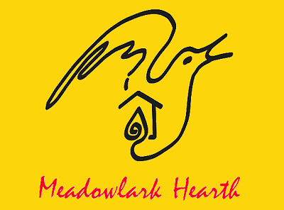
Meadowlark Hearth Living Environment Foundation is a Nebraska 501(c)(3) nonprofit.
Your contribution is tax-deductible. Enclosed is my contribution:
❑$10 ❑ $25 ❑ $50 ❑ $100 ❑ $250 ❑ $500 ❑ $1000 ❑ Other______________
Apply my donation to: ❑ General Support ❑ Seed Saving, Bio-Diversity ❑ Educational programs for farmers, Youth and People with all kinds of special needs ❑ Purchase and retain organic land in perpetuity
TOTAL Enclosed $ _________________
Mail checks to: Meadowlark Hearth Living Environment Foundation, 120024 Everett Drive, Scottsbluff, NE 69361

